**1. What is software? Explain Types of software.**

Software is a collection of instructions, data, or programs used to operate computers and execute specific tasks. It is the intangible component of computers, contrasting with the physical hardware.

Types of Software:

System Software: Manages the hardware components and provides a platform for running application software. Examples include operating systems like Windows, macOS, and Linux.

Application Software: Helps users perform specific tasks. Examples include word processors, spreadsheets, and web browsers.

Programming Software: Provides tools to write, test, and debug programs. Examples include compilers, interpreters, and debuggers.

**2. Explain the SDLC Each phase process.**

Software Development Life Cycle (SDLC) is a process used by the software industry to design, develop, and test high-quality software. It has several phases:

Requirement Analysis: Gather and analyze the requirements from stakeholders.

Design: Create the architecture of the system, defining the data flow and interfaces.

Implementation (Coding): Translate the design into executable code.

Testing: Verify that the software meets the specified requirements and fix any bugs.

Deployment: Release the software for use.

Maintenance: Update the software to correct faults, improve performance, or adapt to a changed environment.

**3. Create the DFD and use case of Flipkart.**

**DFD Diagram:**

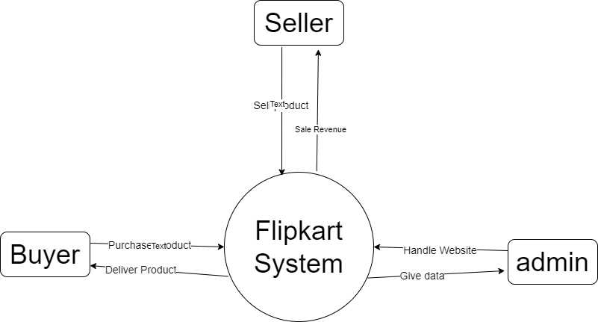

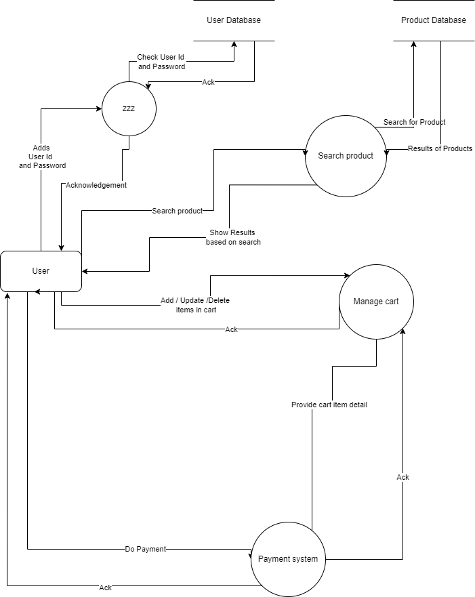

**Use Case:**

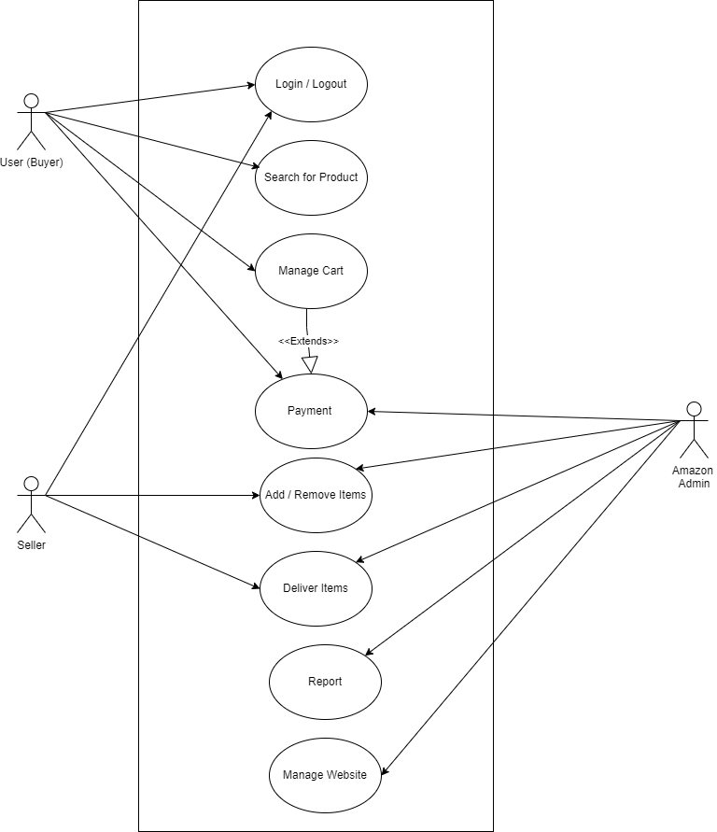

**4. Create the DFD and use case of ATM system.**

**DFD:**

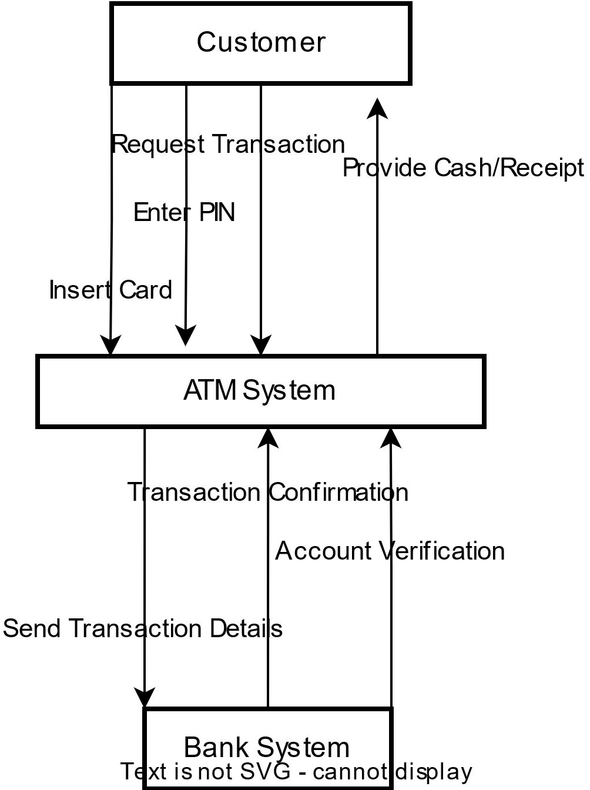

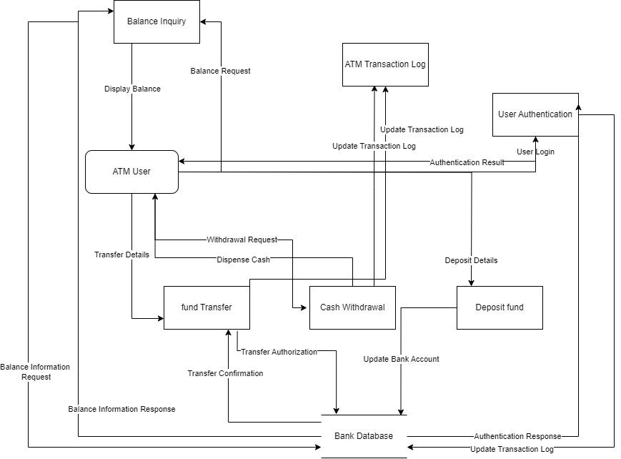

**Use Case:** 

